# Database lab report – 03

**NAME:** Ashiqur Rahman Saron

**Id:** 22-48697-3

* **Creating Table:**

Create table Student(student_id varchar(20), student_name varchar(30),marks number,grade varchar(2));

* + **Updating a new column:** ALTER TABLE student ADD remarks VARCHAR2(100);
  + 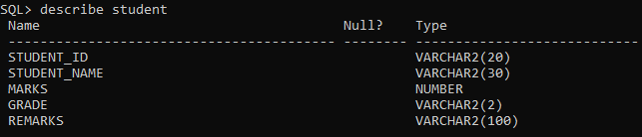**Describing the table:** DESCRIBE Student
* **Inserting the values:**

INSERT INTO student (STUDENT_ID, STUDENT_NAME, MARKS, GRADE, REMARKS)

2 VALUES ('GA-001', 'John', 80, 'A', 'Pass');

INSERT INTO student (STUDENT_ID, STUDENT_NAME, MARKS, GRADE, REMARKS)

2 VALUES ('GA-002', 'Jane', 65, 'B', 'Pass');

INSERT INTO student (STUDENT_ID, STUDENT_NAME, MARKS, GRADE, REMARKS)

2 VALUES ('GA-003', 'David', 45, 'C', 'Fail');

INSERT INTO student (STUDENT_ID, STUDENT_NAME, MARKS, GRADE, REMARKS)

2 VALUES ('GA-004', 'Emily', 70, 'B', 'Pass');

INSERT INTO student (STUDENT_ID, STUDENT_NAME, MARKS, GRADE, REMARKS)

2 VALUES ('GA-005', 'Michael', 55, 'C', 'Fail');

INSERT INTO student (STUDENT_ID, STUDENT_NAME, MARKS, GRADE, REMARKS)

2 VALUES ('GA-006', 'Sophia', 90, 'A', 'Pass');

INSERT INTO student (STUDENT_ID, STUDENT_NAME, MARKS, GRADE, REMARKS)

2 VALUES ('GA-007', 'William', 75, 'B', 'Pass');

INSERT INTO student (STUDENT_ID, STUDENT_NAME, MARKS, GRADE, REMARKS)

2 VALUES ('GA-008', 'Olivia', 35, 'D', 'Fail');

INSERT INTO student (STUDENT_ID, STUDENT_NAME, MARKS, GRADE, REMARKS)

2 VALUES ('GA-009', 'Daniel', 60, 'C', 'Fail');

INSERT INTO student (STUDENT_ID, STUDENT_NAME, MARKS, GRADE, REMARKS)

2 VALUES ('GA-010', 'Mia', 85, 'A', 'Pass');

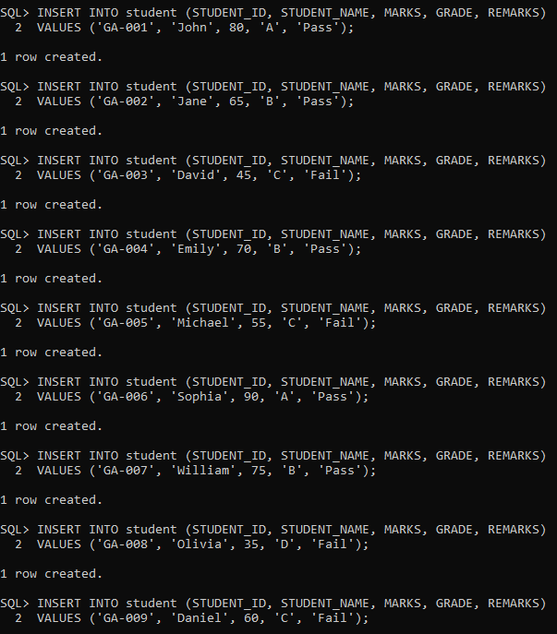

* + **Adding the percentage column:**
    - **Altering the table:**

UPDATE student SET percentage = (MARKS / 100) * 100;

* + - **Updating student percentage:**

UPDATE student SET percentage = (MARKS / 100) * 100;

* **Showcasing the table:** SELECT * from student;

